Title of the article
(Times New Roman; Size 14; Blod; 1 Interline)

Surname and NAME ¹, Surname and NAME², Surname and NAME ³
(Times New Roman; Size 11; 1 Interline)
¹ Full affiliation (Country), Email address, (Times New Roman; size-10)
² Full affiliation (Country), Email address, (times new roman; size-10)
³Full affiliation (Country), Email address, (times new roman; size-10)

Received: Month /Day /Year ; Accepted: Month / Day /Year ; Published: Month / Day /Year

Abstract :
The abstract should not exceed a maximum of 200 words
(Times New Roman font, size 12, 1 interline).

Keywords: Keyword1; Keyword2; Keyword3; Keyword4.

Times New Roman; Size 12; 1 Interline.
- Introduction.
2. First Level Title one.
2.1. Second Level Title one.
a. Third Level Title one
3. First Level Title two.
  - Second Level Title two.
a. Third Level Title two

Figure 1. Title
(Excel Chart, Diagram, Image, etc. Placed in a frame)
(Example)
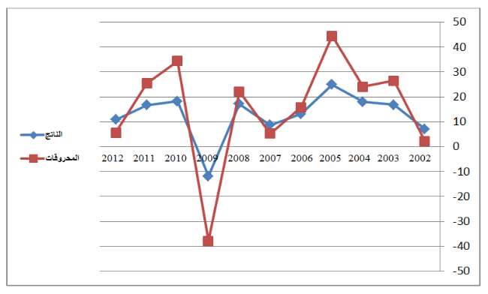

Source : …(New Times Roman11; 1 interlines).

Table 1. Title
(Example)

Test 1 | Test 2 | Results 1 | Results 2 | Total Results
15.21 | 15.21 | 15.21 | 15.21 | 15.21
18.58 | 18.58 | 18.58 | 18.58 | 18.58
11.14 | 11.14 | 11.14 | 11.14 | 11.14

Source : …(New Times Roman11; 1 interlines).

- Results and discussion.

- Conclusion.
Mention the main findings of the article, and the most important recommendations and suggestions must be presented, and it is preferable to offer perspectives for research.
List of references:
- References are important to the reader, so every quote should be complete and correct, by putting each quote verbatim in quotes.
- Marginalization should be automatic at the bottom of the page, in Times New Roman font size 10 (by applying the Reference style).
- All bibliographic references should be numbered in Times New Roman size 12.
- The reference number, in the text, should be put between brackets, for example ⁽¹⁾.
1- Books: Author, book title, place of publication, publisher, year of publication.
2- Journals: Author, "Article Title", Journal Name and Information, Volume, Issue, Year.
3- Scientific forums: Author, "the title of the paper", the title of the forum, the place, the date
4- Websites: The full name of the researcher, the title of the research, and other information such as the place of submission of the work (and the date), then this site or link should be completely and accurately mentioned, and the date of the last access.

